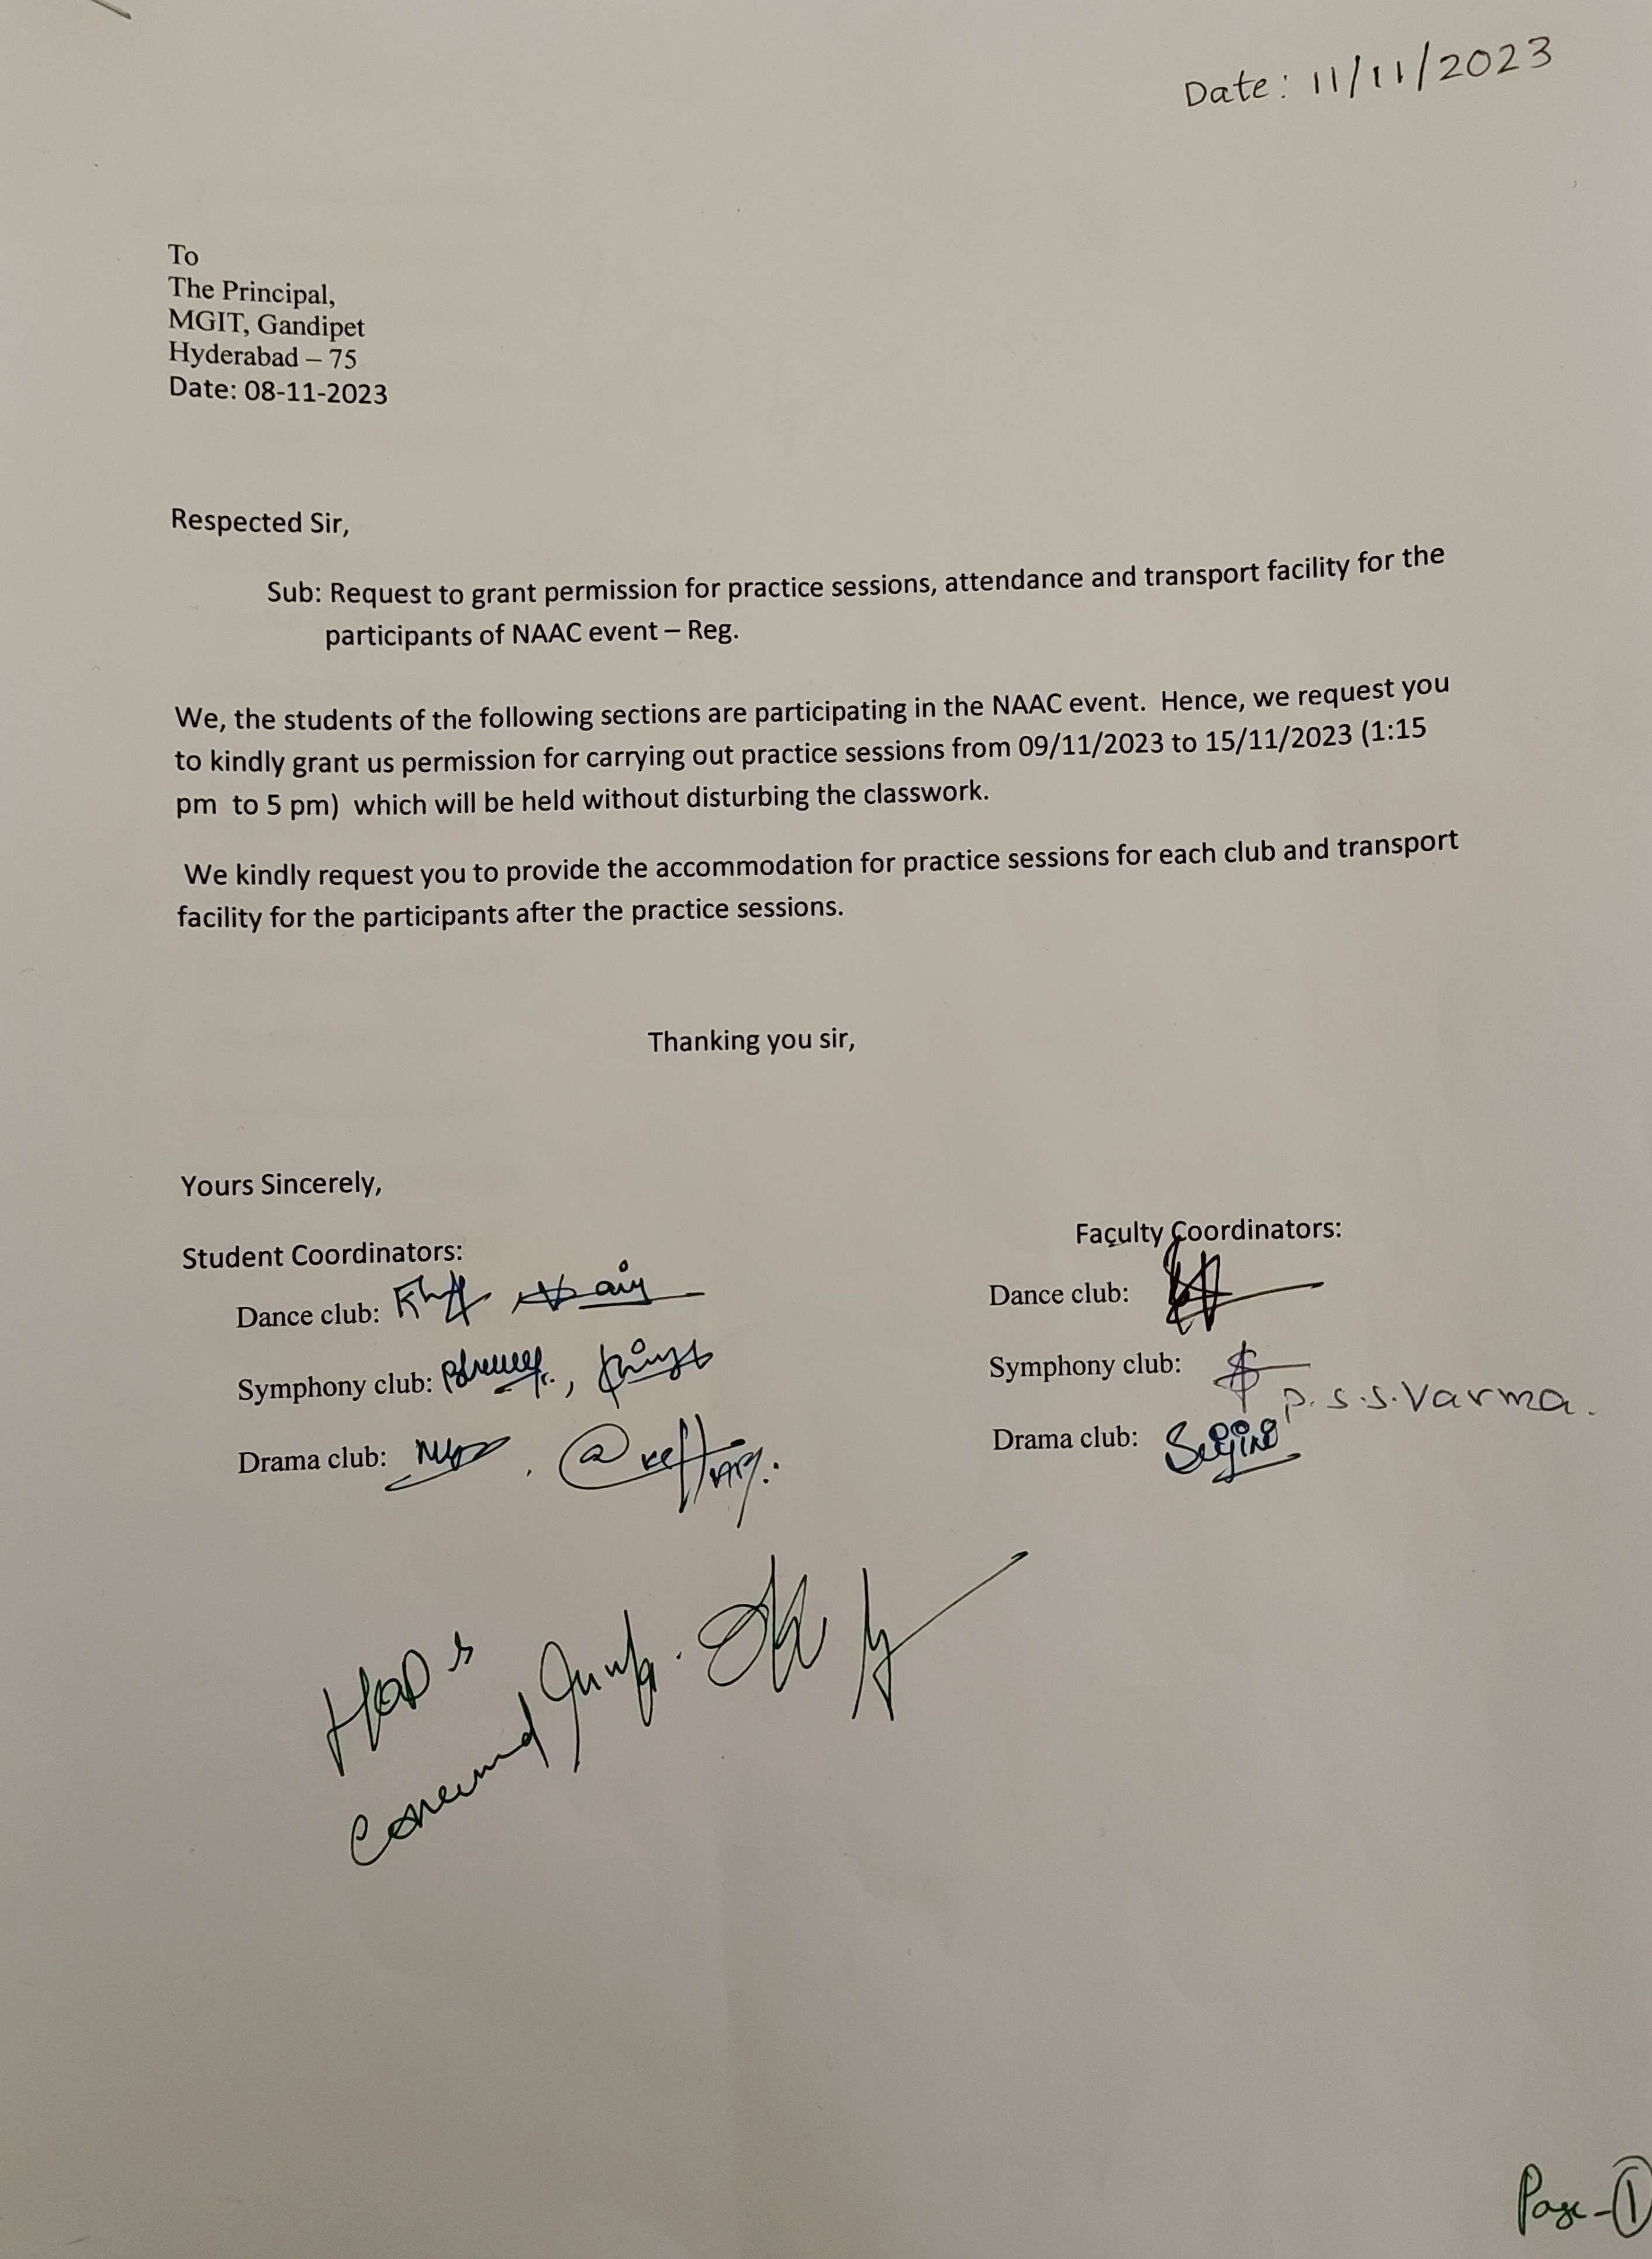

Scanned with ACE Scanner

LIST OF PARITCIPANTS OF MUSIC CLUB:

1.T BHARGAV -21261A6757 2.TSNA CHINMAYEE-21261A6660 3.Pratheek Jadhav-22261A6617 4.VVK Sree Lasya- 22261A05J9 5.Ch Koustubha-22261A6714 6.Khushii Guptaa-21261A3232 7.Akshar-21261A04A5 8.Anudeep George-21261A0568 9.Vasanth-22261A0433

10.James-22261A3207

11.Nikhil Simon-22261A0510 12.Geetanjali-21261A05H8 13.Charan-22261A6658

LIST OF PARTICIPANTS OF DANCE CLUB:

1. 21261A0585 - Ishitha 2. 22261A3234-Shamitha

3. 22261A3261-Keerthija 4. 22261A0428-K.Heeralal 5. 22261A6721 - Rithika 6. 22261A0121-charitha

7. 22261A0135 - RAYMOND

8.22261A05B8 - Poojitha 9.21261A0129 - Sunay

10. 21261A04F7 - Preetam 11. 22261A6710 - Prajna

12.22261A0427 - Sindhura 13.22265A0102 - Helen.

14.22261A04F8- Lasya

15.22261A0113-jessica

LIST OF PARTICIPANTS OF DRAMA CLUB:

1.Akshar-21261A04A5

2.Nitin-21261A6707

3. Alekhya - 22261A0435 4.Eshwar-21261A0574

5.Rushyanjan -21261A0584 6.Rohith-21261A0577

7.Venkat-21261A05G1

8.Bhaweesh-22261A6657 9.Bhuvan-21261A1803

10. Sindhura - 22261A0427

11. Aishwarya-21261A05A4

12. Sruti-21261A05B6

13. Shriya-21261A1235

14.Shivani-21261A0573